**Fusha kurrikulare**: Gjuhë dhe Komunikim  
**Tema mësimore**: Përralla “Kësulëkuqja”

**Rezultatet e të nxënit**:

1. Kupton veprimet e personazheve
2. Liston veprimet e personazheve sipas pamjeve të dhëna
3. Përgjigjet saktë rreth pyetjeve nga përralla
4. Ritregon përrallën “ Kësulëkuqja”

**Materiali i nevojshëm :**

-Filmi i animuar “ Kësulëkuqja”

- Kompjuteri

**Përshkrimi i aktivitetit:**

Nxënësve iu shfaqet filmi i animuar “Kësulëkuqja” dhe iu kërkohet që ta ndjekin me vëmendje.

**AKTIVITETI 1**

**Nxënësve iu parashtrohen pyetjet:**

* Si titullohet përralla?
* A ju pëlqeu?
* Cilat ishin personazhet e përrallës?
* Cili ishte personazhi më i frikshëm i përrallës?

**Prisni me durim që fëmija të përgjigjet në pyetjet tuaja, ndihmojeni gjatë përgjigjeve .**

Përrallat rrëfejnë histori dhe japin elementet e rrëfimit.

Përrallat zhvillojnë imagjinatën e fëmijës.

Përrallat u japin prindërve mundësinë që t’u përcjellin fëmijëve aftësi të të menduarit .

Përrallat japin mësime – morale; ku e mira është e mirë dhe e keqja është e keqe.

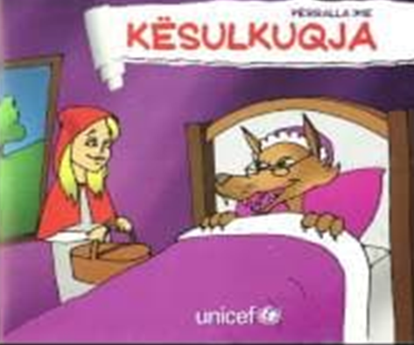 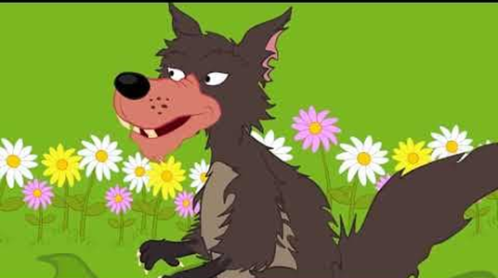

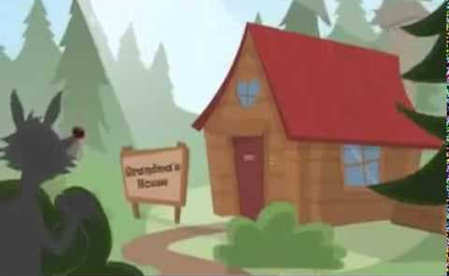 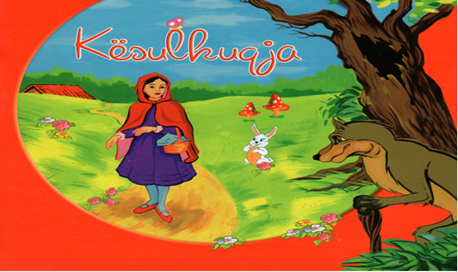

***AKTIVITETI 2***

Pasi që keni diskutuar më fëmijën tuaj për Kësulëkuqen dhe pasi ta keni mbaruar aktivitetin me numër 1, së bashku më fëmijën tuaj bëni një përshkrim të përrallës edhe në fletoren tuaj të punës :

**KËSULËKUQJA**

____________________________________________________________________________________________________________________________________________________________________________________________________________________________________________________________________________________________________________________________________________________________________________________________________________________________________________________________________________________________________________________________________________________________________________________________________________________________________________________________________________________________________________________________________________________________________________________________________________________________________________________________________________________________________________________________________________________________________________________________________________________________________________________________________________________________________________________________________________________________________________________________________________________________________________________________________________________________________________________________________________________________________________________________________________________________________________________________________________________________________________________________________________________________________________________________________________________________________________________________________________________________________________________________________________________________________________________________________________________________________________________________________________________________________________________________________________________________________________________________________________________________________________________________________________________________________________________________________________________________________________________________________________________________________________________________________________________________________________________________________.

